CO1 ASSIGNMENT
EXPERIMENT – 2
LOGICAL, BIT-MANIPULATION AND SHIFT OPERATIONS USING 8-BIT AND 16-BIT DATA MANIPULATION
Course / Subject | Microprocessors and Microcontrollers (MPMC)
Course & Course code | CO1 & ECA1009
Bloom’s Taxonomy Level | K3 – Apply
Work Knowledge Level | WK3 – Engineering Fundamentals
Simulator | 8085 Simulator Software Kit
Student Name | Harineeshree S
Register Number | 192512162
Department | Electronics and Communication Engineering (ECE)
This assignment includes two sub-experiments: Sub-experiment 1 (Verification of Bit Masking Operations Using 8-Bit Processor Assembly Language Programming) and Sub-experiment 2 (Testing of Bit Setting and Clearing Operations Using 8-Bit Assembly Language Programming).
INDEX
S. No. | Contents | Page
1 | Aim, objectives, outcomes and requirements | 2
2 | Theory and instruction set | 3
3 | Sub-experiment 1: Verification of bit masking and logical operations | 4–5
4 | Sub-experiment 2: Testing of bit setting, clearing, shift and rotate operations | 6–7
5 | Result, precautions, observation table and viva-voce questions | 8–9
1. AIM
To develop, execute and verify Intel 8085 assembly-language programs for logical operations (AND, OR, XOR), bit masking, bit setting, bit clearing, bit toggling, bit testing, one's and two's complement of 8-bit and 16-bit data, rotate operations, and logical/arithmetic shift operations using operands stored in memory. The experiment also aims to store the results in specified memory locations, analyze condition flags (S, Z, AC, P, CY) by comparing simulator output with manual bit-wise calculations, and interpret immediate, direct, and register-indirect addressing modes.
Objectives
• Develop and execute assembly programs for bitwise AND, OR, XOR, NOT (one's complement), and NEG (two's complement) on 8-bit and 16-bit data stored in memory.
• Apply bit masking to select, isolate, set, clear, toggle, and test individual bits of a data byte.
• Perform circular rotate (RLC, RRC), logical shift (RAL, RAR with cleared CY), arithmetic shift (sign-preserving RAR), and 16-bit shift left (DAD H) operations, analyzing the carry flag after each step.
• Count the number of set bits (1s) in a byte using rotate and conditional branch loops.
• Verify every result against manual bit-wise calculations with zero deviation.
Expected outcomes
• Obtain sum, masked nibbles, logical combinations, complements, and shifted/rotated results in the specified memory locations.
• Select the correct bit mask for any bit manipulation requirement (setting, clearing, toggling, or testing).
• Analyze the result and carry flag after rotate and shift operations, and distinguish logical from arithmetic shifts.
• Explain flag register behavior, specifically why AND operations set AC=1 while OR/XOR clear both AC and CY.
• Verify all observed simulator outputs against theoretical manual derivations with zero deviation.
Software / hardware required
• Computer or laptop with Intel 8085 Simulator Software Kit 1.0.
• 8085 Microprocessor Trainer Kit, keyboard, and power cord (if hardware verification is conducted).
• Assembly-language editor, assembler, and simulator execution control grid.
2. FUNDAMENTAL THEORY
The Intel 8085 is an 8-bit microprocessor equipped with an Arithmetic Logic Unit (ALU) that performs bitwise logical operations, rotation, and complementation. Logical instructions operate bit-by-bit between the accumulator and an internal register, memory location, or immediate byte value.
1. AND Operation (ANA / ANI): Performs Rn = An · Bn. A 0 in the mask clears the bit, while a 1 preserves it. In 8085 architecture, AND operations inherently reset CY to 0 and set AC to 1.
2. OR Operation (ORA / ORI): Performs Rn = An + Bn. A 1 in the mask sets the bit, while a 0 preserves it. Resets both CY and AC to 0.
3. XOR Operation (XRA / XRI): Performs Rn = An ⊕ Bn. A 1 in the mask toggles the bit, while a 0 preserves it. Resets both CY and AC to 0.
4. Complementation: One's complement is implemented using CMA (A <- NOT A), which does not affect any flags. Two's complement is obtained by adding 1 (CMA followed by INR A). For 16-bit words held in HL, both bytes are complemented and incremented using INX H.
5. Rotate and Shift: RLC and RRC perform 8-bit circular rotation where the bit shifted out is also copied into CY. RAL and RAR perform 9-bit rotation through CY. Logical shift left (multiplication by 2) and logical shift right (unsigned division by 2) require clearing CY (ORA A) prior to RAL or RAR. Arithmetic shift right maintains the sign bit by duplicating D7 into CY before RAR. 16-bit shift left is performed by DAD H (HL <- HL + HL).
Important instructions
Instruction | Purpose
ANA r / M | Logical AND register or memory with accumulator; CY=0, AC=1.
ANI data | Logical AND immediate 8-bit data with accumulator; CY=0, AC=1.
ORA r / M | Logical OR register or memory with accumulator; CY=0, AC=0.
ORI data | Logical OR immediate 8-bit data with accumulator; CY=0, AC=0.
XRA r / M | Logical XOR register or memory with accumulator; CY=0, AC=0.
XRI data | Logical XOR immediate 8-bit data with accumulator; CY=0, AC=0.
CMA | Inverts all bits of the accumulator (one's complement); flags unaffected.
RLC / RRC | Rotate accumulator left / right circular; CY receives bit shifted out.
RAL / RAR | Rotate accumulator left / right through carry (9-bit rotation).
DAD rp | Adds 16-bit register pair to HL; updates CY flag (DAD H shifts HL left).
INX rp | Increments 16-bit register pair by 1; flags unaffected.
PUSH / POP | Saves / restores 16-bit register pair or PSW to/from stack.
HLT | Stops program execution.
Flag register
The 8085 flag register consists of Sign (S), Zero (Z), Auxiliary Carry (AC), Parity (P) and Carry (CY). Sign indicates MSB status, Zero indicates a null result, and Parity is set to 1 if the result contains an even number of set bits. In logical operations, ANA/ANI set AC=1, whereas ORA/XRA clear AC=0. CMA alters no condition flags.
Memory convention: 16-bit data are stored in little-endian order. For example, 4321H is stored as 21H at the lower address and 43H at the next address.
3. SUB-EXPERIMENT 1 — VERIFICATION OF BIT MASKING OPERATIONS USING 8-BIT PROCESSOR ASSEMBLY LANGUAGE PROGRAMMING
Aim
To perform bitwise AND, OR, XOR operations, isolate upper and lower nibbles using masking, and compute 8-bit and 16-bit one's and two's complements using Intel 8085 assembly instructions, storing results and flags in memory.
Input and output memory map
Address | Description | Value
4500H | Operand X | 6BH
4501H | Operand Y | 55H
4502H | Result of X AND Y | 41H
4503H | Result of X OR Y | 7FH
4504H | Result of X XOR Y | 3EH
4505H | Lower nibble (X AND 0FH) | 0BH
4506H | Upper nibble (X AND F0H) | 60H
4507H | One's complement of X | 94H
4508H | Two's complement of X | 95H
4509H | Flags after ANA instruction | 14H
450AH | 16-bit word W (lower byte) | 21H
450BH | 16-bit word W (upper byte) | 43H
450CH | 16-bit 1's complement (lower byte) | DEH
450DH | 16-bit 1's complement (upper byte) | BCH
450EH | 16-bit 2's complement (lower byte) | DFH
450FH | 16-bit 2's complement (upper byte) | BCH
Theory and calculation
Operands: X = 6BH (0110 1011_2), Y = 55H (0101 0101_2).
AND: 6BH · 55H = 0100 0001_2 = 41H. Result has two 1s -> even parity (P = 1); S = 0, Z = 0; ANA sets AC = 1, CY = 0 -> Flag byte = 0001 0100_2 = 14H.
OR: 6BH + 55H = 0111 1111_2 = 7FH. XOR: 6BH ⊕ 55H = 0011 1110_2 = 3EH.
Lower nibble mask: 6BH · 0FH = 0BH. Upper nibble mask: 6BH · F0H = 60H.
8-bit 1's complement: NOT 6BH = FFH - 6BH = 94H. 2's complement: 94H + 1 = 95H (Check: 6BH + 95H = 100H -> CY=1).
16-bit word W = 4321H: 1's complement = FFFFH - 4321H = BCDEH (DEH at 450CH, BCH at 450DH). 2's complement = BCDEH + 1 = BCDFH (DFH at 450EH, BCH at 450FH).
Algorithm
• Initialize the stack pointer to 47FFH and point HL to 4500H.
• Load operand X into A and operand Y into B using register indirect addressing.
• Execute ANA B, save accumulator and flags on the stack with PUSH PSW, and store result at 4502H.
• Pop the stack into HL; copy register L (flags) into A and store at 4509H.
• Reload X into A, perform ORA B, and store at 4503H; reload X, perform XRA B, and store at 4504H.
• Reload X, mask with ANI 0FH and store at 4505H; reload X, mask with ANI F0H and store at 4506H.
• Reload X, complement using CMA and store at 4507H; increment A using INR A and store at 4508H.
• Load 16-bit word W into HL from 450AH; complement L and H using CMA and store at 450CH using SHLD.
• Increment HL using INX H to form the 16-bit two's complement and store at 450EH using SHLD.
• Stop execution with HLT.
Assembly-language program (starting address 8000H)
LXI SP,47FFH
LXI H,4500H
MOV A,M
INX H
MOV B,M
ANA B
PUSH PSW
STA 4502H
POP H
MOV A,L
STA 4509H
LDA 4500H
ORA B
STA 4503H
LDA 4500H
XRA B
STA 4504H
LDA 4500H
ANI 0FH
STA 4505H
LDA 4500H
ANI F0H
STA 4506H
LDA 4500H
CMA
STA 4507H
INR A
STA 4508H
LHLD 450AH
MOV A,L
CMA
MOV L,A
MOV A,H
CMA
MOV H,A
SHLD 450CH
INX H
SHLD 450EH
HLT
Procedure
• Open the 8085 simulator and enter the program starting at address 8000H.
• Set input values in the User Data Grid: 6BH at 4500H, 55H at 4501H, 21H at 450AH, and 43H at 450BH.
• Assemble and execute the program using the Run / Execute button.
• Inspect memory locations 4502H through 450FH and verify the CPU flags and registers.
• Compare observed values with manual theoretical calculations.
Expected output
Operation | Expected result
AND Operation (4502H) | 41H
OR Operation (4503H) | 7FH
XOR Operation (4504H) | 3EH
Lower / Upper Nibble (4505H, 4506H) | 0BH, 60H
8-bit 1's / 2's Complement (4507H, 4508H) | 94H, 95H
Flag Byte after ANA (4509H) | 14H (S=0, Z=0, AC=1, P=1, CY=0)
16-bit 1's / 2's Complement (450CH, 450EH) | BCDEH, BCDFH
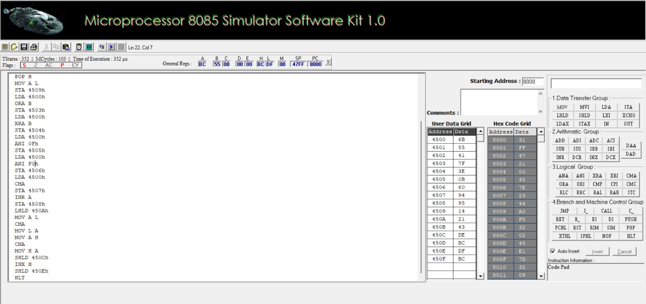
Figure 1. 8085 simulator screenshot for Sub-experiment 1: Verification of bit masking and logical operations.
4. SUB-EXPERIMENT 2 — TESTING OF BIT SETTING AND CLEARING OPERATIONS USING 8-BIT ASSEMBLY LANGUAGE PROGRAMMING
Aim
To perform bit setting, bit clearing, bit toggling, bit testing, circular rotation (RLC, RRC), logical shift left/right (RAL, RAR), arithmetic shift right, bit-level 1-counting, and 16-bit left shift on operands stored in memory using Intel 8085 assembly language.
Input and output memory map
Address | Description | Value
4510H | Data byte D | CAH
4511H | Set bits 7 and 0 (ORI 81H) | CBH
4512H | Clear bits 3 and 1 (ANI F5H) | C0H
4513H | Toggle lower nibble (XRI 0FH) | C5H
4514H | Bit-6 status (01H if set, else 00H) | 01H
4515H | Rotate Left Circular (RLC) | 95H (CY=1)
4516H | Rotate Right Circular (RRC) | 65H (CY=0)
4517H | Logical Shift Left (RAL, CY=0) | 94H (CY=1)
4518H | Logical Shift Right (RAR, CY=0) | 65H (CY=0)
4519H | Arithmetic Shift Right (RAR, signed) | E5H
451AH | Total count of 1s in D | 04H
4520H | 16-bit word for shift (lower byte) | 34H
4521H | 16-bit word for shift (upper byte) | 92H
4522H | 16-bit shift left (lower byte) | 68H
4523H | 16-bit shift left (upper byte) | 24H (CY=1)
Theory and calculation
Input data byte: D = CAH = 1100 1010_2.
Set bits 7 & 0: CAH OR 81H = 1100 1010_2 + 1000 0001_2 = 1100 1011_2 = CBH.
Clear bits 3 & 1: CAH AND F5H = 1100 1010_2 · 1111 0101_2 = 1100 0000_2 = C0H.
Toggle lower nibble: CAH XOR 0FH = 1100 1010_2 ⊕ 0000 1111_2 = 1100 0101_2 = C5H.
Test bit 6: CAH AND 40H = 0100 0000_2 != 0 -> Z=0, bit 6 is 1 -> status stored = 01H.
Rotate circular: RLC gives 1001 0101_2 = 95H with CY=1; RRC gives 0110 0101_2 = 65H with CY=0.
Logical shifts (with cleared CY): Logical shift left (RAL) gives 1001 0100_2 = 94H with CY=1; Logical shift right (RAR) gives 0110 0101_2 = 65H with CY=0.
Arithmetic shift right: Preserves sign bit D7 (1) in CY -> RAR yields 1110 0101_2 = E5H. Signed verification: -54 / 2 = -27 (E5H).
Count of 1s: Rotating 1100 1010_2 eight times yields four carries -> count = 04H.
16-bit shift left: 9234H + 9234H = 12468H -> HL = 2468H with CY=1 (stored 68H at 4522H, 24H at 4523H).
Algorithm
• Load byte D from 4510H, set bits 7 and 0 with ORI 81H, and store at 4511H.
• Reload D, clear bits 3 and 1 with ANI F5H, and store at 4512H.
• Reload D, toggle lower nibble with XRI 0FH, and store at 4513H.
• Clear register C to 00H. Reload D, test bit 6 with ANI 40H. If non-zero, increment C to 01H. Store at 4514H.
• Reload D, execute RLC and store at 4515H; reload D, execute RRC and store at 4516H.
• Reload D, clear CY with ORA A, execute RAL (logical shift left) and store at 4517H.
• Reload D, clear CY with ORA A, execute RAR (logical shift right) and store at 4518H.
• Reload D into B, move sign bit into CY via RAL, reload D into A, execute RAR (arithmetic shift right) and store at 4519H.
• Initialize bit counter B = 08H and 1s counter C = 00H. In loop CNT, rotate next bit into CY using RLC; on carry, increment C. Decrement B and loop until 8 bits are tested. Store count at 451AH.
• Load 16-bit word from 4520H into HL via LHLD, execute DAD H to perform 16-bit left shift, and store at 4522H via SHLD.
• Stop execution with HLT.
Assembly-language program (starting address 8000H)
LDA 4510H
ORI 81H
STA 4511H
LDA 4510H
ANI 0F5H
STA 4512H
LDA 4510H
XRI 0FH
STA 4513H
MVI C,00H
LDA 4510H
ANI 40H
JZ NEXT
INR C
NEXT: MOV A,C
STA 4514H
LDA 4510H
RLC
STA 4515H
LDA 4510H
RRC
STA 4516H
LDA 4510H
ORA A
RAL
STA 4517H
LDA 4510H
ORA A
RAR
STA 4518H
LDA 4510H
MOV B,A
RAL
MOV A,B
RAR
STA 4519H
LDA 4510H
MVI B,08H
MVI C,00H
CNT: RLC
JNC SKIP
INR C
SKIP: DCR B
JNZ CNT
MOV A,C
STA 451AH
LHLD 4520H
DAD H
SHLD 4522H
HLT
Procedure
• Enter the program into the simulator starting at address 8000H.
• Enter CAH at 4510H, 34H at 4520H, and 92H at 4521H in the User Data Grid.
• Assemble and execute the program using the simulator run controls.
• Inspect memory locations 4511H through 451AH and 4522H–4523H.
• Verify CPU registers (A=04H, B=00H, C=04H, H=24H, L=68H, CY=1) and record all outputs.
• Compare practical outputs with manual calculations.
Expected output
Operation | Expected result
Set bits 7 & 0 (4511H) | CBH
Clear bits 3 & 1 (4512H) | C0H
Toggle lower nibble (4513H) | C5H
Bit-6 status (4514H) | 01H
RLC / RRC (4515H, 4516H) | 95H (CY=1), 65H (CY=0)
Logical Shift Left / Right (4517H, 4518H) | 94H (CY=1), 65H (CY=0)
Arithmetic Shift Right (4519H) | E5H
Count of 1s (451AH) | 04H
16-bit Shift Left (4522H–4523H) | 2468H (CY=1)
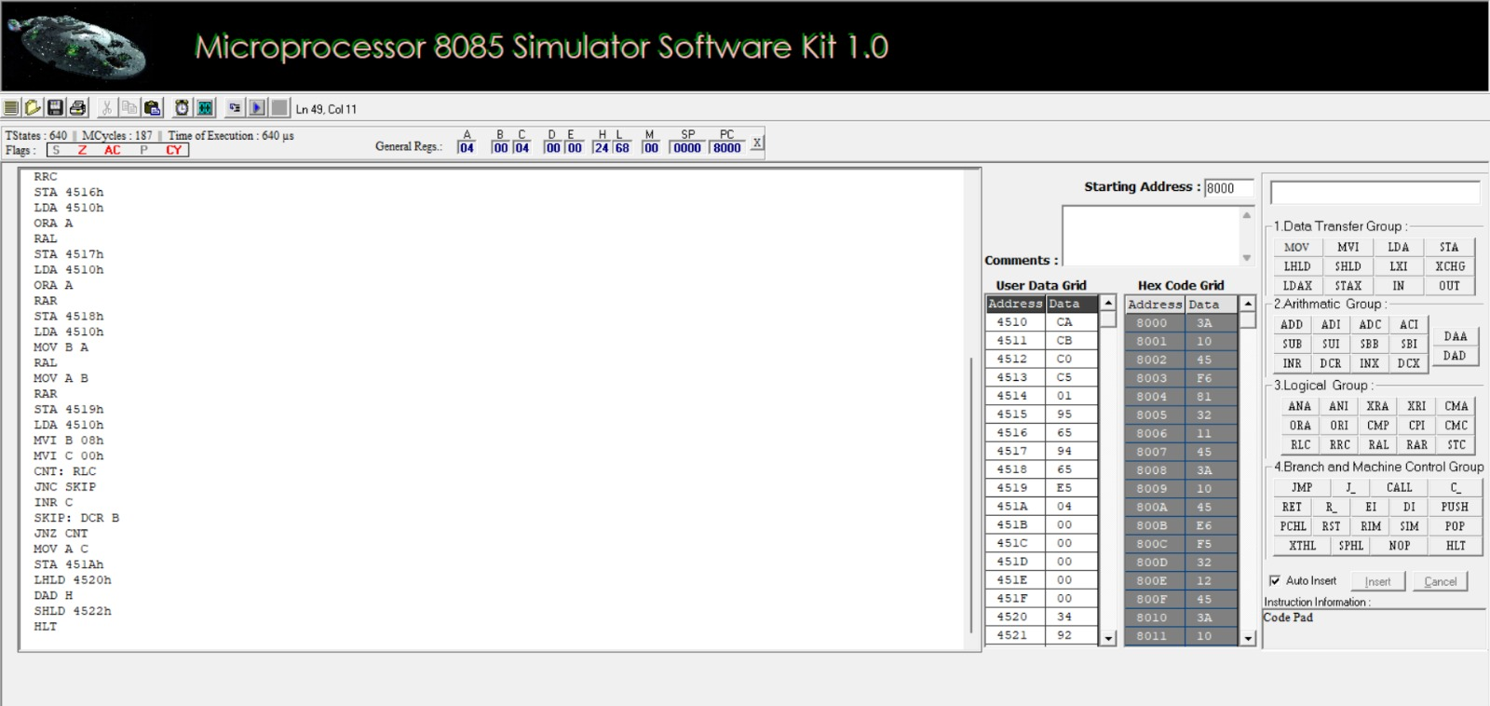
Figure 2. 8085 simulator screenshot for Sub-experiment 2: Bit setting, clearing, shift and rotate operations.
5. COMBINED OBSERVATION TABLE
S. No. | Operation / Parameter | Address | Theoretical Value | Practical / Observed Value | Deviation
1 | Operand X | 4500H | 6BH | 6BH | 0
2 | Operand Y | 4501H | 55H | 55H | 0
3 | X AND Y | 4502H | 41H | 41H | 0
4 | X OR Y | 4503H | 7FH | 7FH | 0
5 | X XOR Y | 4504H | 3EH | 3EH | 0
6 | Lower Nibble Mask | 4505H | 0BH | 0BH | 0
7 | Upper Nibble Mask | 4506H | 60H | 60H | 0
8 | 8-bit 1's Complement | 4507H | 94H | 94H | 0
9 | 8-bit 2's Complement | 4508H | 95H | 95H | 0
10 | Flags after ANA | 4509H | 14H (P=1, AC=1) | 14H | 0
11 | 16-bit Word W | 450AH–450BH | 4321H | 4321H | 0
12 | 16-bit 1's Complement | 450CH–450DH | BCDEH | BCDEH | 0
13 | 16-bit 2's Complement | 450EH–450FH | BCDFH | BCDFH | 0
14 | Data Byte D | 4510H | CAH | CAH | 0
15 | Set Bits 7 and 0 | 4511H | CBH | CBH | 0
16 | Clear Bits 3 and 1 | 4512H | C0H | C0H | 0
17 | Toggle Lower Nibble | 4513H | C5H | C5H | 0
18 | Bit-6 Status | 4514H | 01H | 01H | 0
19 | RLC Result | 4515H | 95H (CY=1) | 95H (CY=1) | 0
20 | RRC Result | 4516H | 65H (CY=0) | 65H (CY=0) | 0
21 | Logical Shift Left | 4517H | 94H (CY=1) | 94H (CY=1) | 0
22 | Logical Shift Right | 4518H | 65H (CY=0) | 65H (CY=0) | 0
23 | Arithmetic Shift Right | 4519H | E5H | E5H | 0
24 | Total 1s in D | 451AH | 04H | 04H | 0
25 | 16-bit Word for Shift | 4520H–4521H | 9234H | 9234H | 0
26 | 16-bit Shift Left (DAD H) | 4522H–4523H | 2468H (CY=1) | 2468H (CY=1) | 0
6. RESULT
The two sub-experiments cover logical operations (AND, OR, XOR), bit masking, bit setting, clearing, toggling, testing, circular rotation, logical and arithmetic shifts, bit-level counting, and 16-bit data manipulation using Intel 8085 assembly language programming. The programs demonstrate register-indirect addressing, immediate masking, stack preservation, condition flag updates, and loop-based bit analysis. All practical memory outputs and register states observed in the simulator kit matched the theoretical calculations exactly with zero deviation.
• Always initialize the stack pointer (LXI SP, 47FFH) before executing stack operations (PUSH PSW, POP H) to avoid corrupting program instructions or data memory.
• For logical shift operations using RAL or RAR, clear the carry flag beforehand using ORA A to prevent extraneous carry bits from rotating into the operand.
• In arithmetic shift right operations, preserve the sign bit (D7) in the carry flag before executing RAR to ensure proper sign extension for signed numbers.
• Enter 16-bit values strictly in little-endian order (lower byte at lower address, higher byte at upper address).
• Verify loop termination conditions and bit counters to avoid indefinite execution loops.
• Record actual simulator outputs rather than copying expected theoretical values as observations.
Viva-Voce Questions & Key Insights
1. Why does ANA B set the Auxiliary Carry (AC) flag while ORA B clears it?
Answer: The Intel 8085 ALU hardware is architected such that logical AND instructions (ANA, ANI) unconditionally set AC = 1 to support BCD logical testing, whereas OR and XOR instructions unconditionally reset both AC and CY to 0.
2. What is the difference between RLC and RAL?
Answer: RLC performs an 8-bit circular rotation where bit D7 rotates into D0 and is simultaneously copied into CY. RAL performs a 9-bit rotation through CY, where D7 enters CY and the previous contents of CY enter D0.
3. How does an Arithmetic Shift Right differ from a Logical Shift Right?
Answer: A logical shift right shifts all bits right and inserts a 0 into the MSB (D7), treating the value as an unsigned number (division by 2). An arithmetic shift right preserves the sign bit (D7) by duplicating it into the MSB, correctly dividing signed 2's complement numbers by 2 (e.g., CAH = -54_10 -> E5H = -27_10).
4. Why is 80H its own two's complement?
Answer: In 8-bit signed representation, 80H represents -128_10. Inverting 80H (1000 0000) gives 7FH (0111 1111), and adding 1 yields 80H (1000 0000). Because +128 cannot be represented in standard 8-bit signed format (range -128 to +127), -128 is its own complement.
5. How does DAD H perform a 16-bit shift left?
Answer: DAD H performs the 16-bit addition HL <- HL + HL. Adding any binary number to itself is equivalent to multiplying by 2 (X * 2), which shifts the entire 16-bit word left by one bit position, placing the most significant bit into the Carry flag.
Laboratory Performance Assessment Rubric
Objective | Assessment Criterion | Excellent – 4 | Good – 3 | Satisfactory – 2 | Needs Improvement – 1 | Weight (%)
Develop bit masking & logical programs | Program Development & Execution | Develops and executes correct AND, OR, XOR, mask, and complement programs independently with proper result storage | Correct work with minor errors and limited assistance | Partially correct; needs considerable assistance | Unable to complete or results incorrect | 25
Develop bit setting, clearing & shift programs | Mask Selection & Bit Handling | Selects correct masks for every set, clear, toggle, and test operation; uses rotate and shift instructions correctly | Correct work with minor errors and limited assistance | Partially correct; needs considerable assistance | Unable to complete or results incorrect | 25
Analyze flag register | Flag & CY Analysis | Predicts and verifies S, Z, AC, P, and CY after logical, rotate, and shift operations | Correct work with minor errors and limited assistance | Partially correct; needs considerable assistance | Unable to complete or results incorrect | 30
Verify results against theory | Manual Verification & Justification | Verifies all results bit by bit with zero deviation and justifies the mask and shift type used | Correct work with minor errors and limited assistance | Partially correct; needs considerable assistance | Unable to complete or results incorrect | 20

